UNITED STATES
SECURITIES AND EXCHANGE COMMISSION
Washington, D.C. 20549

FORM 8-K

CURRENT REPORT
Pursuant to Section 13 or 15(d) of the Securities Exchange Act of 1934

Date of Report (Date of earliest event reported): August 12, 2026

LIQUIDIA CORPORATION
(Exact name of registrant as specified in its charter)
Delaware | 001-39724 | 85-1710962
(State or other jurisdiction  of incorporation) | (Commission  File Number) | (IRS Employer  Identification No.)

419 Davis Drive, Suite 100, Morrisville, North Carolina | 27560
(Address of principal executive offices) | (Zip Code)

Registrant’s telephone number, including area code: (919) 328-4400
(Former name or former address, if changed since last report.)

Check the appropriate box below if the Form 8-K filing is intended to simultaneously satisfy the filing obligation of the registrant under any of the following provisions (see General Instruction A.2. below):

☐ Written communications pursuant to Rule 425 under the Securities Act (17 CFR 230.425)

☐ Soliciting material pursuant to Rule 14a-12 under the Exchange Act (17 CFR 240.14a-12)

☐ Pre-commencement communications pursuant to Rule 14d-2(b) under the Exchange Act (17 CFR 240.14d-2(b))

☐ Pre-commencement communications pursuant to Rule 13e-4(c) under the Exchange Act (17 CFR 240.13e-4(c))

Securities registered pursuant to Section 12(b) of the Act:

Title of each class | Trading Symbol(s) | Name of each exchange on which registered
Common stock | LQDA | The Nasdaq Stock Market LLC

Indicate by check mark whether the registrant is an emerging growth company as defined in Rule 405 of the Securities Act of 1933 (§230.405 of this chapter) or Rule 12b-2 of the Securities Exchange Act of 1934 (§240.12b-2 of this chapter).

Emerging growth company ☐

If an emerging growth company, indicate by check mark if the registrant has elected not to use the extended transition period for complying with any new or revised financial accounting standards provided pursuant to Section 13(a) of the Exchange Act. ☐

Item 2.02 | Results of Operations and Financial Condition.

On August 12, 2026, Liquidia Corporation, a Delaware corporation (the “Company”), issued a press release announcing its financial results for the quarter ended June 30, 2026, and also provided a corporate update. A copy of the press release is furnished herewith as Exhibit 99.1.*

Item 8.01 | Other Events.

On August 12, 2026, the Company updated its corporate presentation that it uses for presentations at healthcare conferences and to analysts, current stockholders, and others. A copy of the Company's presentation that it intends to use at such events is filed herewith as Exhibit 99.2 and is incorporated herein by reference.

Item 9.01 | Financial Statements and Exhibits.

(d)

Exhibit  No. |  | Exhibit
99.1 |  | Press Release of Liquidia Corporation, dated August 12, 2026.
99.2 |  | Liquidia Corporation Corporate Presentation - August 2026.
104 |  | Cover Page Interactive Data File (embedded within the Inline XBRL document).

* The information in Item 2.02 of this Form 8-K shall not be deemed “filed” for purposes of Section 18 of the Securities Exchange Act of 1934, as amended (the “Exchange Act”), or otherwise subject to the liabilities of that section, nor shall it be deemed incorporated by reference in any filing under the Securities Act of 1933, as amended, or the Exchange Act, except as expressly set forth by specific reference in such a filing.

SIGNATURES

Pursuant to the requirements of the Securities Exchange Act of 1934, the registrant has duly caused this report to be signed on its behalf by the undersigned hereunto duly authorized.

August 12, 2026 | Liquidia Corporation
 | By: | /s/ Michael Kaseta
 |  | Name: Michael Kaseta
 |  | Title: Chief Financial Officer and Chief Operating Officer

Exhibit 99.1

Liquidia Corporation Reports Second Quarter 2026 Financial Results

 | • | YUTREPIA® (treprostinil) inhalation powder net product sales of approximately $170.4 million in the second quarter of 2026, up 31% from the first quarter of 2026

 | • | Approximately 5,900 unique patient prescriptions and more than 5,000 patients treated between launch in June 2025 and July 31, 2026

 | • | Recorded fourth consecutive quarter of increasing profitability, with net income of $74.7 million, adjusted EBITDA of $96.3 million and an increase in cash and cash equivalents of $61.4 million compared to the first quarter of 2026

 | • | Progressing 10 clinical studies supporting YUTREPIA and L606 across known and new indications for inhaled treprostinil

MORRISVILLE, N.C., August 12, 2026 – Liquidia Corporation (NASDAQ: LQDA), a biopharmaceutical company driven by science and compassion to revolutionize care for patients with challenging respiratory and vascular diseases, today reported financial results for the second quarter ended June 30, 2026. The company will also host a webcast at 8:30 a.m. ET on August 12, 2026, to discuss its financial results and provide a corporate update.

Dr. Roger Jeffs, Liquidia’s Chief Executive Officer, said: “We are pleased by the sustained adoption of YUTREPIA as the inhaled prostacyclin of choice. The inhaled category has grown almost 40% since launch, and YUTREPIA has captured an ever-increasing share of that growth. We are building on that momentum by strengthening the clinical evidence for YUTREPIA in PAH and PH-ILD patients transitioning from other therapies, and advancing studies in new indications that may broaden its impact. Having reset the bar for tolerability and dose flexibility with YUTREPIA, we are excited to have begun site activation and enrollment in Re-Spire, our pivotal study for L606, which we believe can raise that bar even further, beyond any therapy currently available or in development.”

YUTREPIA Commercial Launch Highlights (as of July 31, 2026)

 | • | Received approximately 5,900 unique patient prescriptions since launch in June 2025

 | • | Started more than 5,000 patients on treatment since launch in June 2025

 | • | Prescription-to-start conversion remained strong above the 85% level as previously reported

 | • | Increased total number of prescribers to more than 1,100 since launch, of which more than 30% have prescribed YUTREPIA to at least 5 patients

Second Quarter 2026 Financial Results

YUTREPIA sales led to the company’s fourth consecutive quarter of increasing profitability with net income of $74.7 million and positive non-GAAP adjusted EBITDA of $96.3 million in the second quarter of 2026.

Cash and cash equivalents totaled $284.2 million as of June 30, 2026, compared to $190.7 million as of December 31, 2025.

Product sales, net, were $170.4 million for the three months ended June 30, 2026, compared to $6.5 million for the three months ended June 30, 2025. We began shipping YUTREPIA to our customers in the United States in June 2025, following receipt of full FDA approval for YUTREPIA on May 23, 2025. The increase of $163.9 million was due to higher volume of YUTREPIA sales.

Service revenue, net, was $1.3 million for the three months ended June 30, 2026, compared to $2.3 million for the three months ended June 30, 2025. Service revenue, net was related to the promotion agreement with Sandoz, Inc. pursuant to which we share profits from the sale of Treprostinil Injection in the United States. The decrease of $1.0 million was primarily due to the impact of unfavorable gross-to-net adjustments.

Cost of product sales was $10.8 million for the three months ended June 30, 2026, compared to $0.2 million for the three months ended June 30, 2025. Cost of product sales is related to sales of YUTREPIA. The increase of $10.6 million was primarily due to higher volume of YUTREPIA sales.

Research and development expenses were $17.2 million for the three months ended June 30, 2026, compared to $6.0 million for the three months ended June 30, 2025. The increase of $11.2 million or 185% was primarily due to a $7.0 million increase in expenses for our L606 program, a $2.0 million increase in expenses related to our YUTREPIA research and development activities, a $0.9 million increase in personnel expenses driven by higher headcount, and a $1.0 million L606 development milestone recognized during the second quarter of 2026.

Selling, general and administrative expenses were $57.4 million for the three months ended June 30, 2026, compared to $38.8 million for the three months ended June 30, 2025. The increase of $18.6 million or 48% was primarily due to a $10.0 million increase in personnel expenses and a $3.1 million increase in stock-based compensation driven by higher headcount, and an $8.6 million increase in commercial and consulting expenses to support the commercialization of YUTREPIA. These increases were partially offset by a $5.5 million decrease in legal fees related to our ongoing YUTREPIA-related litigation.

Total other expenses, net was $3.8 million for the three months ended June 30, 2026, compared to $4.1 million for the three months ended June 30, 2025. The decrease of $0.3 million was primarily attributable to higher money market balances offset by higher borrowings under our revenue interest financing agreement with HealthCare Royalty Partners IV, L.P.

Income tax expense was $7.0 million for the three months ended June 30, 2026. We did not recognize any income tax expense during the three months ended June 30, 2025.

Net income for the three months ended June 30, 2026, was $74.7 million, or $0.84 per basic and $0.74 per diluted share, as compared to a net loss of $41.6 million, or $0.49 per basic and diluted share, for the three months ended June 30, 2025.

Webcast Information

Liquidia will host a live webcast at 8:30 a.m. Eastern Time on August 12, 2026, to discuss the second quarter 2026 financial results and corporate update. The webcast will be available on Liquidia’s website at https://liquidia.com/investors/events-and-presentations. A rebroadcast of the event will be available and archived for a period of one year at the same location.

About YUTREPIA® (treprostinil) Inhalation Powder

YUTREPIA is an inhaled dry-powder formulation of treprostinil delivered through a convenient, low-effort, palm-sized device. YUTREPIA is indicated for the treatment of PAH and PH-ILD to improve exercise ability. YUTREPIA was designed using Liquidia’s PRINT® technology, which enables the development of drug particles that are precise and uniform in size, shape and composition, and that are engineered for enhanced deposition in the lung following oral inhalation. YUTREPIA was previously referred to as LIQ861 in investigational studies.

About L606 (liposomal treprostinil inhalation suspension)

L606 is an investigational, extended-release formulation of treprostinil administered twice-daily with a next-generation nebulizer. The L606 suspension uses a proprietary liposomal formulation to encapsulate treprostinil which can be released slowly at a controlled rate into the lung, enhancing drug exposure over an extended period of time. L606 is currently being evaluated in an open-label study in the United States for treatment of PAH and PH-ILD and is the subject of Re-Spire, a global pivotal placebo-controlled efficacy study for the treatment of PH-ILD.

About Treprostinil Injection

Treprostinil Injection is the first-to-file, fully substitutable generic treprostinil for parenteral administration. Treprostinil Injection contains the same active ingredient, same strengths, same dosage form and same inactive ingredients as Remodulin® (treprostinil) and is offered to patients and physicians with the same level of service and support, but at a lower price than the branded drug. Liquidia PAH promotes the appropriate use of Treprostinil Injection for the treatment of PAH in the United States in partnership with its commercial partner, Sandoz, who holds the Abbreviated New Drug Application (ANDA) with the FDA.

About Pulmonary Arterial Hypertension (PAH)

PAH is a rare, chronic, progressive disease caused by hardening and narrowing of the pulmonary arteries that can lead to right heart failure and eventually death. Currently, an estimated 45,000 patients are diagnosed and treated in the United States. There is currently no cure for PAH, so the goals of existing treatments are to alleviate symptoms, maintain or improve functional class, delay disease progression and improve quality of life.

About Pulmonary Hypertension Associated with Interstitial Lung Disease (PH-ILD)

PH-ILD includes a diverse collection of up to 150 different pulmonary diseases, including interstitial pulmonary fibrosis, chronic hypersensitivity pneumonitis, connective tissue disease-related ILD, and chronic pulmonary fibrosis with emphysema (CPFE) among others. Any level of PH in ILD patients is associated with poor 3-year survival. A current estimate of PH-ILD prevalence in the United States is greater than 60,000 patients, though actual prevalence in many of these underlying ILD diseases is not yet known due to factors including underdiagnosis and lack of approved treatments until March 2021 when inhaled treprostinil was first approved for this indication.

About Liquidia Corporation

Liquidia Corporation is a biopharmaceutical company driven by science and compassion to revolutionize care for patients with challenging respiratory and vascular diseases through precise, innovative therapies and applications of its proprietary PRINT® technology. PRINT enabled the development of YUTREPIA® (treprostinil) inhalation powder for the treatment of PAH and PH-ILD. The company is also developing L606, an investigational extended-release formulation of treprostinil administered twice-daily with a next-generation nebulizer, and currently markets generic Treprostinil Injection for the treatment of PAH. To learn more about Liquidia, please visit www.liquidia.com.

Abbreviations

1. PAH: pulmonary arterial hypertension. 2. PH-ILD: pulmonary hypertension associated with interstitial lung disease.

Remodulin® is a registered mark of United Therapeutics Corporation.

Cautionary Statements Regarding Forward-Looking Statements

This press release may include forward-looking statements within the meaning of the Private Securities Litigation Reform Act of 1995. All statements contained in this press release other than statements of historical facts, including statements regarding our future results of operations and financial position, our strategic and financial initiatives, our business strategy and plans and our objectives for future operations, are forward-looking statements.

Forward-looking statements, including statements regarding clinical trials, clinical studies and other clinical work (including the funding therefor, anticipated patient enrollment, safety data, study data, trial outcomes, timing or associated costs), regulatory applications and related submission contents and timelines, the timelines or outcomes related to patent litigation with United Therapeutics in the U.S. District Court for the District of Delaware and U.S. District Court for the Middle District of North Carolina, or other litigation between Liquidia and United Therapeutics or others, including rehearings or appeals of decisions in any such proceedings, the issuance of patents by the USPTO and our ability to execute on our strategic or financial initiatives, our estimates regarding future expenses, capital requirements and needs for additional financing, and potential revenue and profitability of YUTREPIA involve significant risks and uncertainties and actual results could differ materially from those expressed or implied herein. Our ability to maintain YUTREPIA’s approval and to continue commercialization of YUTREPIA remain subject to ongoing litigation in which United Therapeutics is seeking injunctive relief, which could block our ability to continue to sell YUTREPIA for one or both of PAH and PH-ILD. The words “anticipate,” “believe,” “continue,” “could,” “estimate,” “expect,” “intend,” “may,” “plan,” “potential,” “predict,” “project,” “should,” “target,” “would,” and similar expressions are intended to identify forward-looking statements. We have based these forward-looking statements largely on our current expectations and projections about future events and financial trends that we believe may affect our financial condition, results of operations, business strategy, short-term and long-term business operations and objectives and financial needs. These forward-looking statements are subject to a number of risks discussed in our filings with the SEC, as well as a number of uncertainties and assumptions. Moreover, we operate in a very competitive and rapidly changing environment and our industry has inherent risks. New risks emerge from time to time. It is not possible for our management to predict all risks, nor can we assess the impact of all factors on our business or the extent to which any factor, or combination of factors, may cause actual results to differ materially from those contained in any forward-looking statements we may make. In light of these risks, uncertainties and assumptions, the future events discussed in this press release may not occur and actual results could differ materially and adversely from those anticipated or implied in the forward-looking statements. Nothing in this press release should be regarded as a representation by any person that these goals will be achieved, and we undertake no duty to update our goals or to update or alter any forward-looking statements, whether as a result of new information, future events or otherwise.

Use of Non-GAAP Financial Information

This press release and the accompanying tables include U.S. Generally Accepted Accounting Principles (GAAP) and non-GAAP financial measures. For a description of such non-GAAP financial measures, including the reasons for using such measures, and reconciliations of such non-GAAP financial measures to the most directly comparable financial measures prepared in accordance with GAAP, please see the section entitled “About Non-GAAP Financial Information” below.

Contact Information

Investors:
Jason Adair
Chief Business Officer
919.328.4350
Jason.adair@liquidia.com

Media:
media@liquidia.com

Liquidia Corporation
Select Consolidated Balance Sheet Data
(in thousands)

 |  | June 30, |  |  |  | December 31,
 |  | 2026 |  |  |  | 2025
Cash and cash equivalents |  | $ | 284,181 |  |  | $ | 190,680
Total assets |  | $ | 521,918 |  |  | $ | 327,934
Total liabilities |  | $ | 326,804 |  |  | $ | 283,186
Accumulated deficit |  | $ | (498,729 | ) |  | $ | (626,313 | )
Total stockholders’ equity |  | $ | 195,114 |  |  | $ | 44,748

Liquidia Corporation
Consolidated Statements of Operations and Comprehensive Income (Loss)
(unaudited)
(in thousands, except share and per share amounts)

 |  | Three Months Ended June 30,
 |  | 2026 |  |  |  | 2025
Revenues:
Product sales, net |  | $ | 170,382 |  |  | $ | 6,517
Service revenue, net |  |  | 1,297 |  |  |  | 2,320
Total revenue |  |  | 171,679 |  |  |  | 8,837
Costs and expenses:
Cost of product sales |  |  | 10,759 |  |  |  | 205
Cost of service revenue |  |  | 791 |  |  |  | 1,292
Research and development |  |  | 17,184 |  |  |  | 6,021
Selling, general and administrative |  |  | 57,428 |  |  |  | 38,824
Total costs and expenses |  |  | 86,162 |  |  |  | 46,342
Income (loss) from operations |  |  | 85,517 |  |  |  | (37,505 | )
Other income (expense):
Interest income |  |  | 2,476 |  |  |  | 1,584
Interest expense |  |  | (6,296 | ) |  |  | (5,658 | )
Total other expense, net |  |  | (3,820 | ) |  |  | (4,074 | )
Income (loss) before income taxes |  |  | 81,697 |  |  |  | (41,579 | )
Income tax expense |  |  | 6,975 |  |  |  | —
Net income (loss) and comprehensive income (loss) |  | $ | 74,722 |  |  | $ | (41,579 | )
Net income (loss) per common share, basic |  | $ | 0.84 |  |  | $ | (0.49 | )
Net income (loss) per common share, diluted |  | $ | 0.74 |  |  | $ | (0.49 | )
Weighted average common shares outstanding, basic |  |  | 88,887,744 |  |  |  | 85,588,108
Weighted average common shares outstanding, diluted |  |  | 101,397,028 |  |  |  | 85,588,108

About Non-GAAP Financial Information

To supplement our financial results presented in accordance with U.S. Generally Accepted Accounting Principles (GAAP), this press release includes certain non-GAAP financial measures, such as Adjusted EBITDA. We believe the use of such non-GAAP financial measures provides investors with additional insight into our operational performance. While we compute non-GAAP financial measures using a consistent method from quarter to quarter and year to year, we may consider whether other significant items that arise in the future should be excluded from our non-GAAP financial measures.

Adjusted EBITDA is a non-GAAP measure that represents net income for the period before the impact of interest income, interest expense, other income and expense, income taxes, depreciation and amortization, and certain items that impact comparison of the performance of our business either period-over-period or with other businesses.

Adjusted EBITDA should not be considered in isolation or as a substitute to net income or any other measure of financial performance calculated and presented in accordance with GAAP. Our calculation of Adjusted EBITDA may not be comparable to similarly titled measures of other companies because other companies may not calculate them in the same manner as we calculate these measures.

For a reconciliation of such non-GAAP financial measures to the most directly comparable financial measures prepared in accordance with GAAP, please see the table titled “Reconciliation of Non-GAAP Financial Information” below.

Liquidia Corporation
Reconciliation of Non-GAAP Financial Information
Reconciliation of Net Income (Loss) to Adjusted EBITDA
(unaudited)
(in thousands)

 |  | Three Months Ended
 |  | June 30,
 |  | 2026
Net income |  | $ | 74,722
Interest expense, net |  |  | 3,820
Income tax expense |  |  | 6,975
Depreciation and amortization |  |  | 400
EBITDA |  | $ | 85,917
Stock-based compensation |  |  | 10,370
Adjusted EBITDA |  | $ | 96,287

Exhibit 99.2

 | 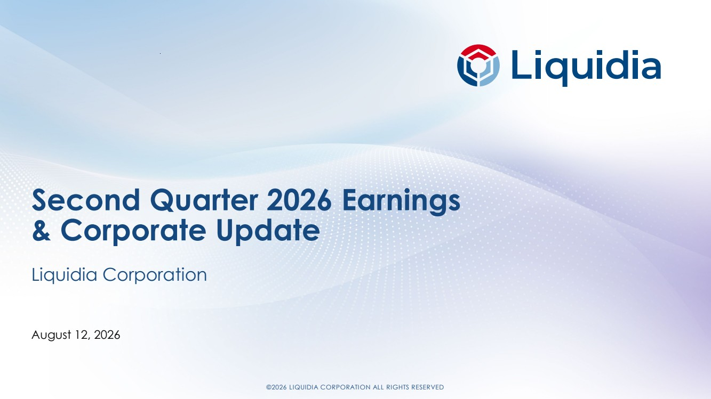 | ©2026 LIQUIDIA CORPORATION ALL RIGHTS RESERVED Second Quarter 2026 Earnings & Corporate Update Liquidia Corporation August 12, 2026
 | 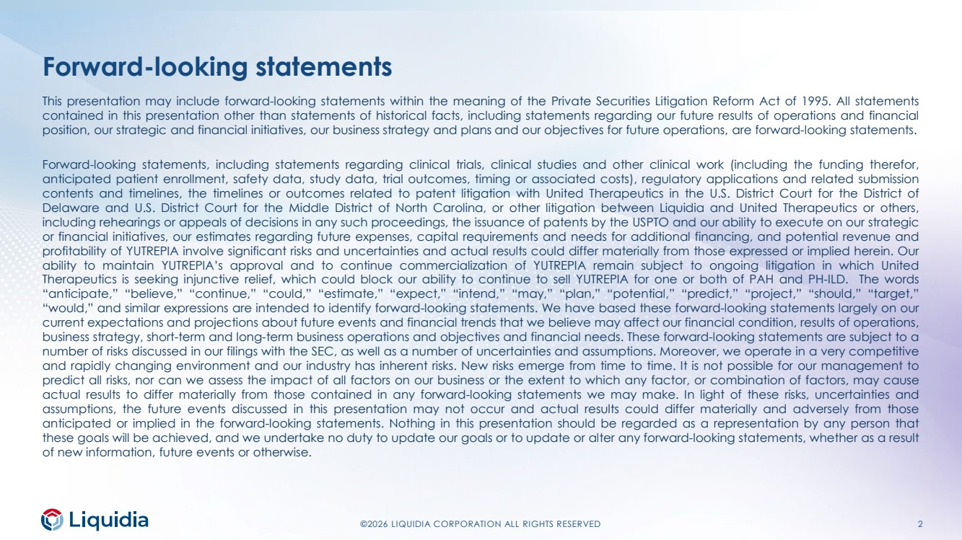 | ©2026 LIQUIDIA CORPORATION ALL RIGHTS RESERVED 2 Forward-looking statements This presentation may include forward-looking statements within the meaning of the Private Securities Litigation Reform Act of 1995. All statements contained in this presentation other than statements of historical facts, including statements regarding our future results of operations and financial position, our strategic and financial initiatives, our business strategy and plans and our objectives for future operations, are forward-looking statements. Forward-looking statements, including statements regarding clinical trials, clinical studies and other clinical work (including the funding therefor, anticipated patient enrollment, safety data, study data, trial outcomes, timing or associated costs), regulatory applications and related submission contents and timelines, the timelines or outcomes related to patent litigation with United Therapeutics in the U.S. District Court for the District of Delaware and U.S. District Court for the Middle District of North Carolina, or other litigation between Liquidia and United Therapeutics or others, including rehearings or appeals of decisions in any such proceedings, the issuance of patents by the USPTO and our ability to execute on our strategic or financial initiatives, our estimates regarding future expenses, capital requirements and needs for additional financing, and potential revenue and profitability of YUTREPIA involve significant risks and uncertainties and actual results could differ materially from those expressed or implied herein. Our ability to maintain YUTREPIA’s approval and to continue commercialization of YUTREPIA remain subject to ongoing litigation in which United Therapeutics is seeking injunctive relief, which could block our ability to continue to sell YUTREPIA for one or both of PAH and PH-ILD. The words “anticipate,” “believe,” “continue,” “could,” “estimate,” “expect,” “intend,” “may,” “plan,” “potential,” “predict,” “project,” “should,” “target,” “would,” and similar expressions are intended to identify forward-looking statements. We have based these forward-looking statements largely on our current expectations and projections about future events and financial trends that we believe may affect our financial condition, results of operations, business strategy, short-term and long-term business operations and objectives and financial needs. These forward-looking statements are subject to a number of risks discussed in our filings with the SEC, as well as a number of uncertainties and assumptions. Moreover, we operate in a very competitive and rapidly changing environment and our industry has inherent risks. New risks emerge from time to time. It is not possible for our management to predict all risks, nor can we assess the impact of all factors on our business or the extent to which any factor, or combination of factors, may cause actual results to differ materially from those contained in any forward-looking statements we may make. In light of these risks, uncertainties and assumptions, the future events discussed in this presentation may not occur and actual results could differ materially and adversely from those anticipated or implied in the forward-looking statements. Nothing in this presentation should be regarded as a representation by any person that these goals will be achieved, and we undertake no duty to update our goals or to update or alter any forward-looking statements, whether as a result of new information, future events or otherwise.
 | 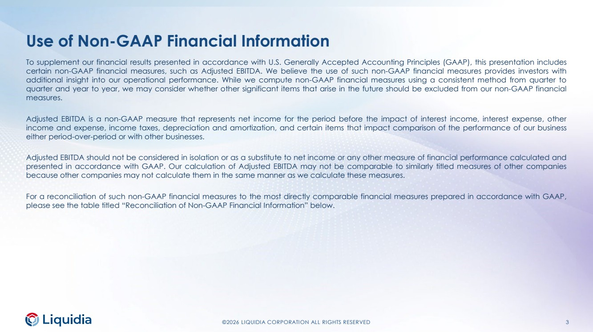 | ©2026 LIQUIDIA CORPORATION ALL RIGHTS RESERVED 3 Use of Non-GAAP Financial Information To supplement our financial results presented in accordance with U.S. Generally Accepted Accounting Principles (GAAP), this presentation includes certain non-GAAP financial measures, such as Adjusted EBITDA. We believe the use of such non-GAAP financial measures provides investors with additional insight into our operational performance. While we compute non-GAAP financial measures using a consistent method from quarter to quarter and year to year, we may consider whether other significant items that arise in the future should be excluded from our non-GAAP financial measures. Adjusted EBITDA is a non-GAAP measure that represents net income for the period before the impact of interest income, interest expense, other income and expense, income taxes, depreciation and amortization, and certain items that impact comparison of the performance of our business either period-over-period or with other businesses. Adjusted EBITDA should not be considered in isolation or as a substitute to net income or any other measure of financial performance calculated and presented in accordance with GAAP. Our calculation of Adjusted EBITDA may not be comparable to similarly titled measures of other companies because other companies may not calculate them in the same manner as we calculate these measures. For a reconciliation of such non-GAAP financial measures to the most directly comparable financial measures prepared in accordance with GAAP, please see the table titled “Reconciliation of Non-GAAP Financial Information” below.
 | 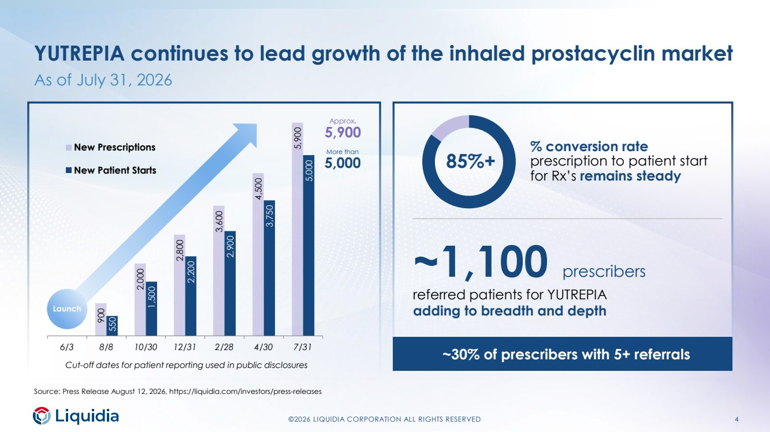 | ©2026 LIQUIDIA CORPORATION ALL RIGHTS RESERVED 4 YUTREPIA continues to lead growth of the inhaled prostacyclin market As of July 31, 2026 900 2,000 2,800 3,600 4,500 5,900 0 550 1,500 2,200 2,900 3,750 5,000 6/3 8/8 10/30 12/31 2/28 4/30 7/31 New Prescriptions New Patient Starts % conversion rate prescription to patient start for Rx’s remains steady 85%+ More than 5,000 Approx. 5,900 Cut-off dates for patient reporting used in public disclosures Source: Press Release August 12, 2026, https://liquidia.com/investors/press-releases ~1,100 prescribers referred patients for YUTREPIA adding to breadth and depth ~30% of prescribers with 5+ referrals Launch
 | 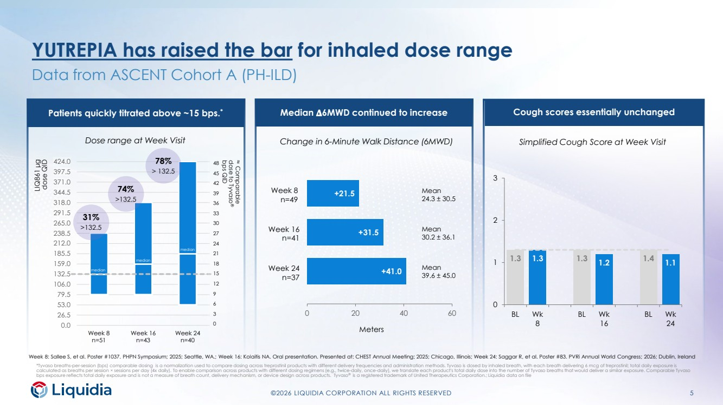 | ©2026 LIQUIDIA CORPORATION ALL RIGHTS RESERVED 5 0.0 26.5 53.0 79.5 106.0 132.5 159.0 185.5 212.0 238.5 265.0 291.5 318.0 344.5 371.0 397.5 424.0 Week 8 n=51 Week 16 n=43 Week 24 n=40 YUTREPIA has raised the bar for inhaled dose range Data from ASCENT Cohort A (PH-ILD) *Tyvaso breaths-per-session (bps) comparable dosing is a normalization used to compare dosing across treprostinil products with different delivery frequencies and administration methods. Tyvaso is dosed by inhaled breath, with each breath delivering 6 mcg of treprostinil; total daily exposure is calculated as breaths per session × sessions per day (4x daily). To enable comparison across products with different dosing regimens (e.g., twice-daily, once-daily), we translate each product's total daily dose into the number of Tyvaso breaths that would deliver a similar exposure. Comparable Tyvaso bps exposure reflects total daily exposure and is not a measure of breath count, delivery mechanism, or device design across products. Tyvaso® is a registered trademark of United Therapeutics Corporation.; Liquidia data on file 48 45 42 39 36 33 30 27 24 21 18 15 12 9 6 3 0 78% > 132.5 74% >132.5 31% >132.5 median ≈ Comparable dose to Tyvaso® bps QID LIQ861 μg dose QID Dose range at Week Visit Change in 6-Minute Walk Distance (6MWD) Simplified Cough Score at Week Visit Week 8: Sallee S, et al. Poster #1037. PHPN Symposium; 2025; Seattle, WA.; Week 16: Kolaitis NA. Oral presentation. Presented at: CHEST Annual Meeting; 2025; Chicago, Illinois; Week 24: Saggar R, et al. Poster #83. PVRi Annual World Congress; 2026; Dublin, Ireland Patients quickly titrated above ~15 bps.* Median 𝚫𝚫6MWD continued to increase Cough scores essentially unchanged median median +41.0 +31.5 +21.5 0 20 40 60 Week 8 n=49 Week 16 n=41 Meters Week 24 n=37 Mean 24.3 ± 30.5 Mean 30.2 ± 36.1 Mean 39.6 ± 45.0 1.3 1.3 1.3 1.2 1.4 1.1 0 1 2 3 BL Wk 8 BL Wk 16 BL Wk 24
 | 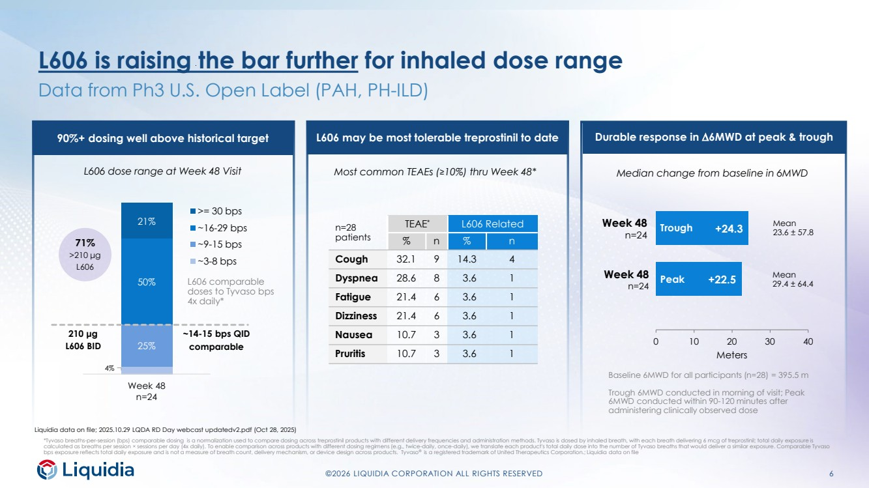 | ©2026 LIQUIDIA CORPORATION ALL RIGHTS RESERVED 6 L606 is raising the bar further for inhaled dose range Data from Ph3 U.S. Open Label (PAH, PH-ILD) *Tyvaso breaths-per-session (bps) comparable dosing is a normalization used to compare dosing across treprostinil products with different delivery frequencies and administration methods. Tyvaso is dosed by inhaled breath, with each breath delivering 6 mcg of treprostinil; total daily exposure is calculated as breaths per session × sessions per day (4x daily). To enable comparison across products with different dosing regimens (e.g., twice-daily, once-daily), we translate each product's total daily dose into the number of Tyvaso breaths that would deliver a similar exposure. Comparable Tyvaso bps exposure reflects total daily exposure and is not a measure of breath count, delivery mechanism, or device design across products. Tyvaso® is a registered trademark of United Therapeutics Corporation.; Liquidia data on file median L606 dose range at Week 48 Visit Most common TEAEs (≥10%) thru Week 48* Median change from baseline in 6MWD Liquidia data on file; 2025.10.29 LQDA RD Day webcast updatedv2.pdf (Oct 28, 2025) 90%+ dosing well above historical target L606 may be most tolerable treprostinil to date Durable response in ∆6MWD at peak & trough median median +22.5 +24.3 0 10 20 30 40 Meters Mean 23.6 ± 57.8 Mean 29.4 ± 64.4 Week 48 n=24 Week 48 n=24 n=28 patients TEAE* L606 Related % n % n Cough 32.1 9 14.3 4 Dyspnea 28.6 8 3.6 1 Fatigue 21.4 6 3.6 1 Dizziness 21.4 6 3.6 1 Nausea 10.7 3 3.6 1 Pruritis 10.7 3 3.6 1 4% 25% 50% 21% Week 48 n=24 >= 30 bps ~16-29 bps ~9-15 bps ~3-8 bps 210 μg L606 BID 71% >210 μg L606 ~14-15 bps QID comparable Trough Peak Baseline 6MWD for all participants (n=28) = 395.5 m Trough 6MWD conducted in morning of visit; Peak 6MWD conducted within 90-120 minutes after administering clinically observed dose L606 comparable doses to Tyvaso bps 4x daily*
 | 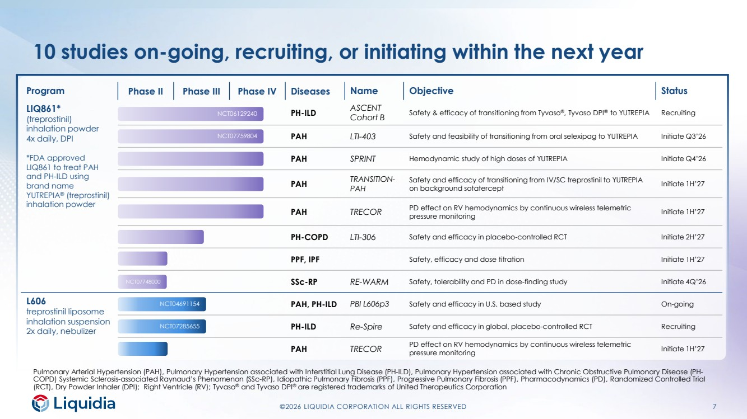 | ©2026 LIQUIDIA CORPORATION ALL RIGHTS RESERVED 7 10 studies on-going, recruiting, or initiating within the next year Pulmonary Arterial Hypertension (PAH), Pulmonary Hypertension associated with Interstitial Lung Disease (PH-ILD), Pulmonary Hypertension associated with Chronic Obstructive Pulmonary Disease (PH-COPD) Systemic Sclerosis-associated Raynaud’s Phenomenon (SSc-RP), Idiopathic Pulmonary Fibrosis (PPF), Progressive Pulmonary Fibrosis (PPF), Pharmacodynamics (PD), Randomized Controlled Trial (RCT), Dry Powder Inhaler (DPI); Right Ventricle (RV); Tyvaso® and Tyvaso DPI® are registered trademarks of United Therapeutics Corporation Program Phase II Phase III Phase IV Diseases Name Objective Status LIQ861* (treprostinil) inhalation powder 4x daily, DPI *FDA approved LIQ861 to treat PAH and PH-ILD using brand name YUTREPIA® (treprostinil) inhalation powder PH-ILD ASCENT Cohort B Safety & efficacy of transitioning from Tyvaso®, Tyvaso DPI® to YUTREPIA Recruiting PAH LTI-403 Safety and feasibility of transitioning from oral selexipag to YUTREPIA Initiate Q3’26 PAH SPRINT Hemodynamic study of high doses of YUTREPIA Initiate Q4’26 PAH TRANSITION-PAH Safety and efficacy of transitioning from IV/SC treprostinil to YUTREPIA on background sotatercept Initiate 1H’27 PAH TRECOR PD effect on RV hemodynamics by continuous wireless telemetric pressure monitoring Initiate 1H’27 PH-COPD LTI-306 Safety and efficacy in placebo-controlled RCT Initiate 2H’27 PPF, IPF Safety, efficacy and dose titration Initiate 1H’27 SSc-RP RE-WARM Safety, tolerability and PD in dose-finding study Initiate 4Q’26 L606 treprostinil liposome inhalation suspension 2x daily, nebulizer PAH, PH-ILD PBI L606p3 Safety and efficacy in U.S. based study On-going PH-ILD Re-Spire Safety and efficacy in global, placebo-controlled RCT Recruiting PAH TRECOR PD effect on RV hemodynamics by continuous wireless telemetric pressure monitoring Initiate 1H’27 NCT04691154 NCT06129240 NCT07759804 NCT07748000 NCT07285655
 | 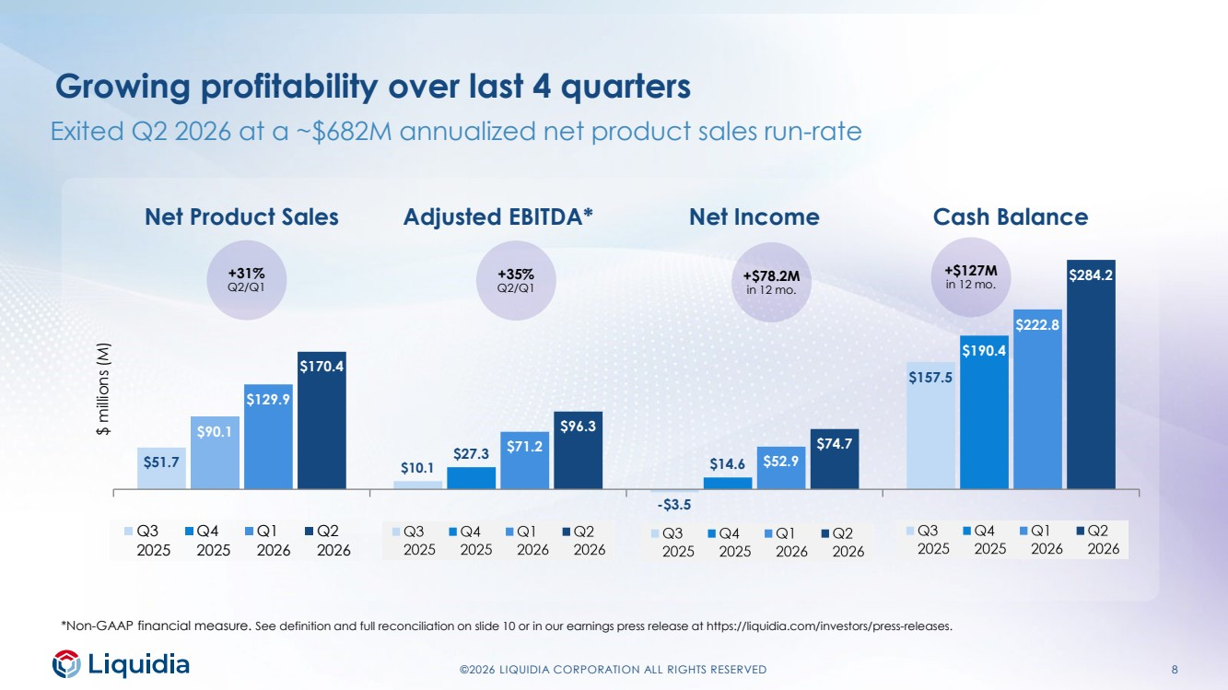 | ©2026 LIQUIDIA CORPORATION ALL RIGHTS RESERVED 8 Exited Q2 2026 at a ~$682M annualized net product sales run-rate $51.7 $10.1 -$3.5 $157.5 $90.1 $27.3 $14.6 $190.4 $129.9 $71.2 $52.9 $222.8 $170.4 $96.3 $74.7 $284.2 Net Product Sales Adjusted EBITDA* Net Income Cash Balance $ millions (M) Q3 2025 Q4 2025 Q1 2026 Q2 2026 *Non-GAAP financial measure. See definition and full reconciliation on slide 10 or in our earnings press release at https://liquidia.com/investors/press-releases. Growing profitability over last 4 quarters +31% Q2/Q1 +35% Q2/Q1 +$78.2M in 12 mo. +$127M in 12 mo.
 | 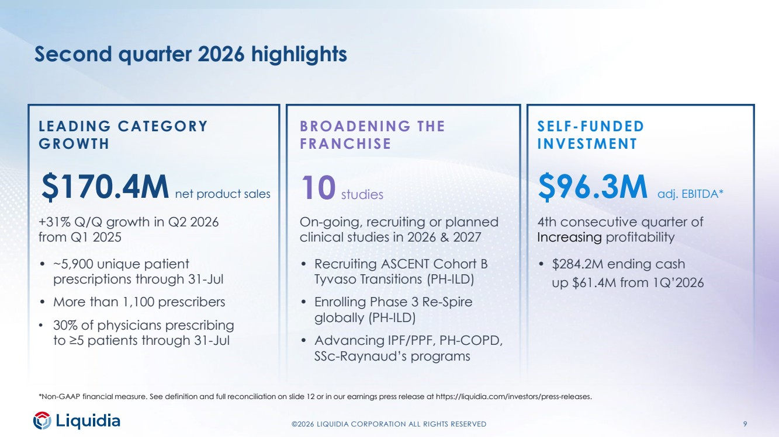 | ©2026 LIQUIDIA CORPORATION ALL RIGHTS RESERVED 9 Second quarter 2026 highlights LEADING CATEGORY GROWTH BROADENING THE FRANCHISE SELF-FUNDED INVESTMENT $170.4M net product sales 10 studies $96.3M adj. EBITDA* +31% Q/Q growth in Q2 2026 from Q1 2025 • ~5,900 unique patient prescriptions through 31-Jul • More than 1,100 prescribers • 30% of physicians prescribing to ≥5 patients through 31-Jul On-going, recruiting or planned clinical studies in 2026 & 2027 • Recruiting ASCENT Cohort B Tyvaso Transitions (PH-ILD) • Enrolling Phase 3 Re-Spire globally (PH-ILD) • Advancing IPF/PPF, PH-COPD, SSc-Raynaud’s programs 4th consecutive quarter of Increasing profitability • $284.2M ending cash up $61.4M from 1Q’2026 *Non-GAAP financial measure. See definition and full reconciliation on slide 12 or in our earnings press release at https://liquidia.com/investors/press-releases.
 | 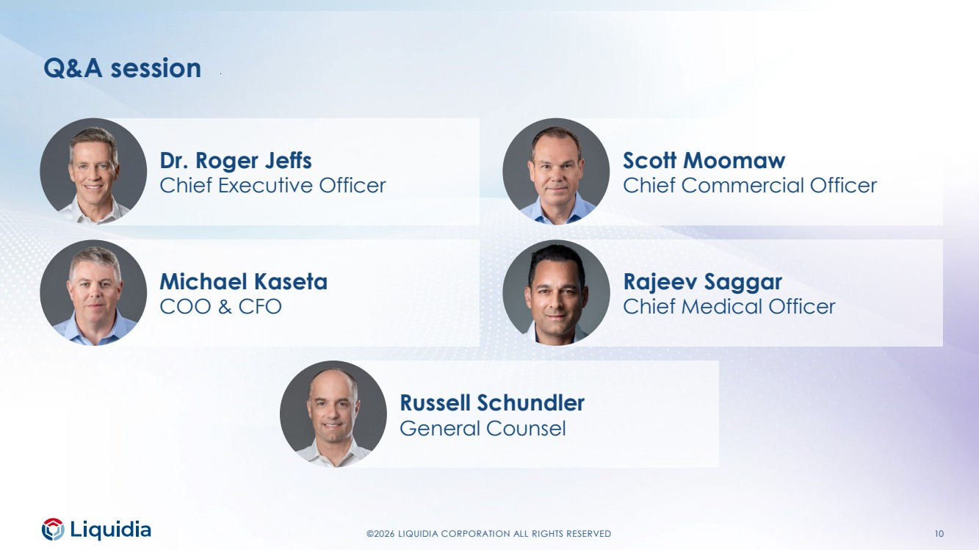 | ©2026 LIQUIDIA CORPORATION ALL RIGHTS RESERVED 10 Scott Moomaw Chief Commercial Officer Rajeev Saggar Chief Medical Officer Dr. Roger Jeffs Chief Executive Officer Michael Kaseta COO & CFO Russell Schundler General Counsel Q&A session
 | 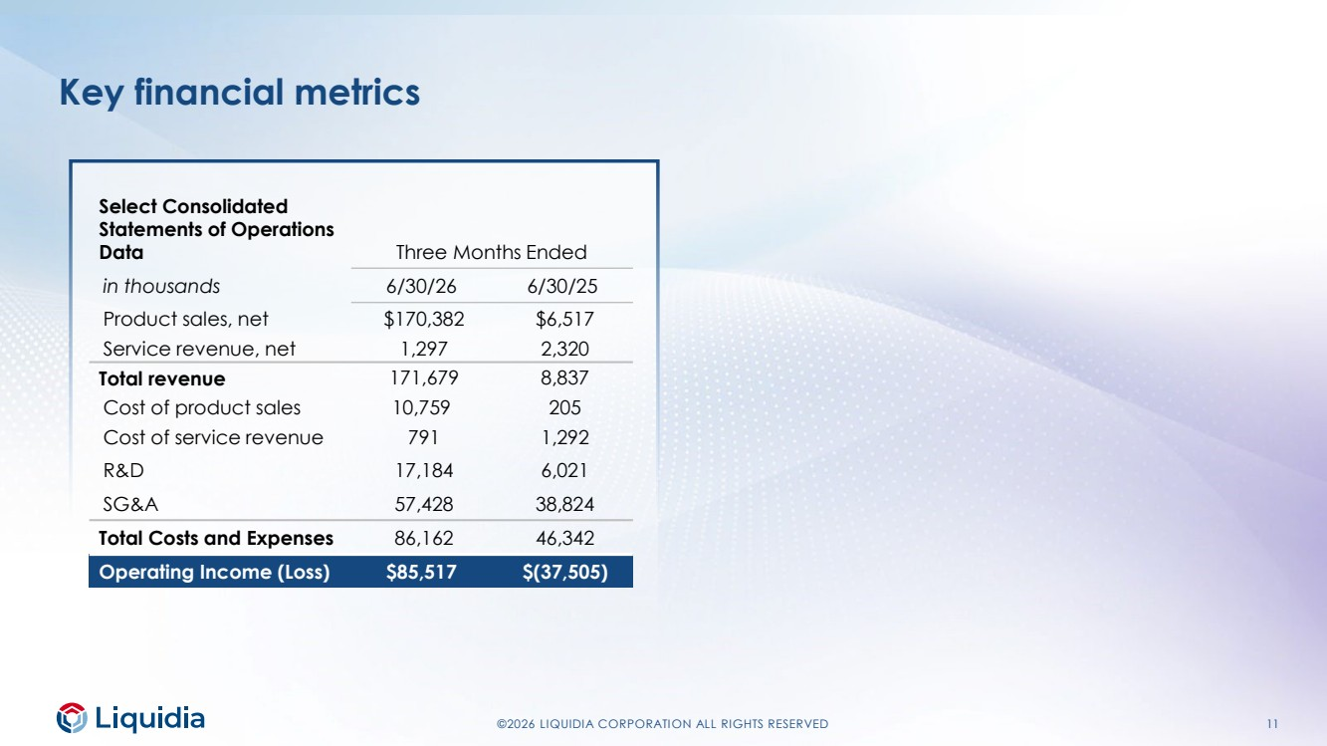 | ©2026 LIQUIDIA CORPORATION ALL RIGHTS RESERVED 11 Key financial metrics Select Consolidated Statements of Operations Data Three Months Ended in thousands 6/30/26 6/30/25 Product sales, net $170,382 $6,517 Service revenue, net 1,297 2,320 Total revenue 171,679 8,837 Cost of product sales 10,759 205 Cost of service revenue 791 1,292 R&D 17,184 6,021 SG&A 57,428 38,824 Total Costs and Expenses 86,162 46,342 Operating Income (Loss) $85,517 $(37,505)
 | 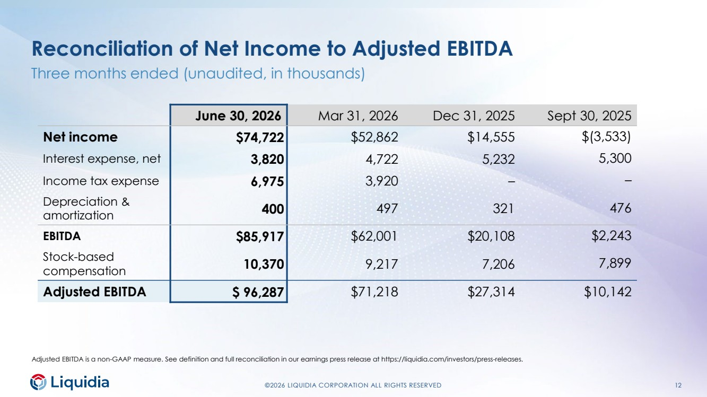 | ©2026 LIQUIDIA CORPORATION ALL RIGHTS RESERVED 12 Reconciliation of Net Income to Adjusted EBITDA Three months ended (unaudited, in thousands) Adjusted EBITDA is a non-GAAP measure. See definition and full reconciliation in our earnings press release at https://liquidia.com/investors/press-releases. June 30, 2026 Mar 31, 2026 Dec 31, 2025 Sept 30, 2025 Net income $74,722 $52,862 $14,555 $(3,533) Interest expense, net 3,820 4,722 5,232 5,300 Income tax expense 6,975 3,920 – – Depreciation & amortization 400 497 321 476 EBITDA $85,917 $62,001 $20,108 $2,243 Stock-based compensation 10,370 9,217 7,206 7,899 Adjusted EBITDA $ 96,287 $71,218 $27,314 $10,142

